8.9: a) Considering the +x-components, and the velocity is 10.8 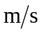in the +x-direction. b) p= 0.48 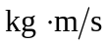+ (–12.0 N)(0.05 s) = –0.12 , and the velocity is +0.75 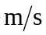 in the –x-direction.

